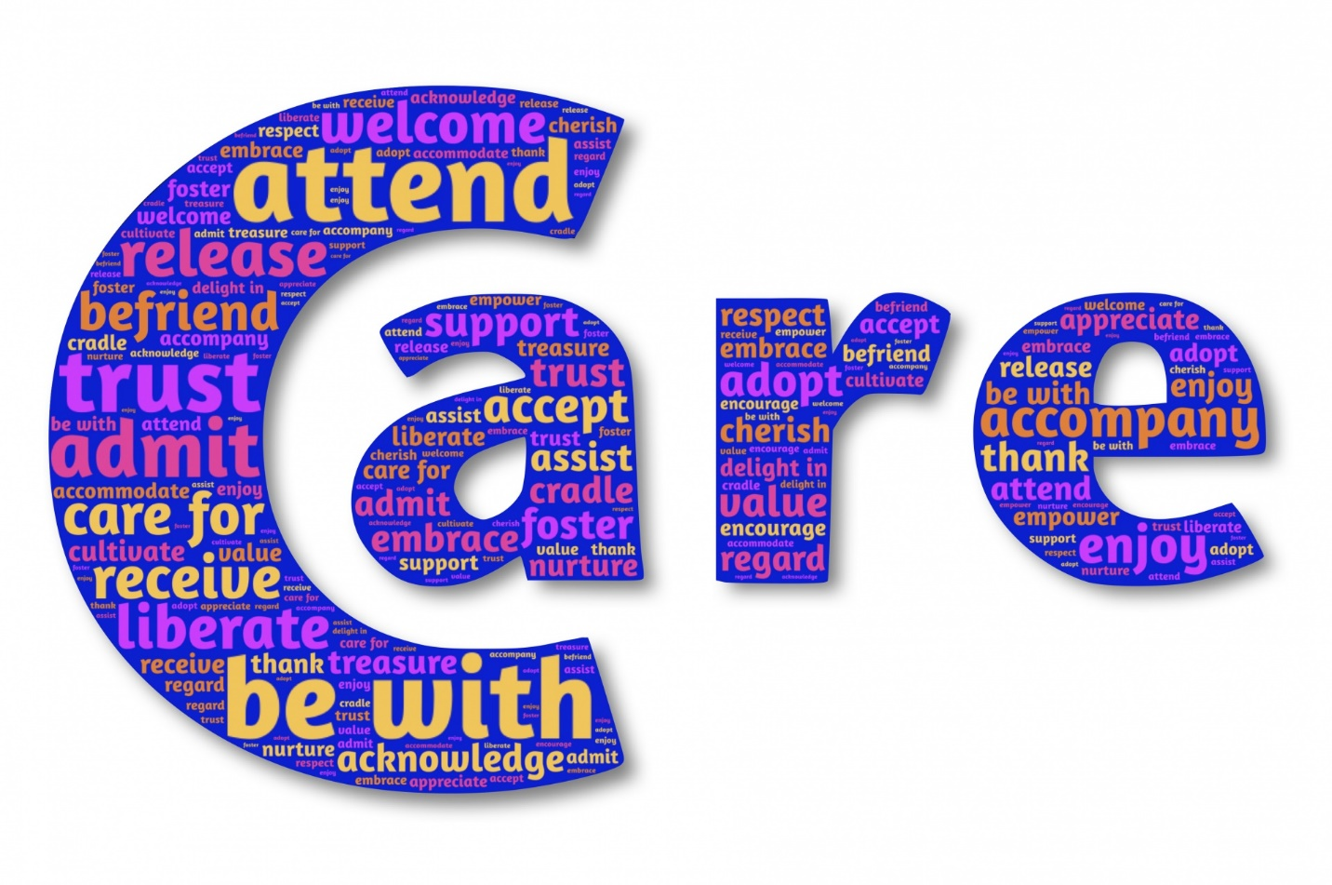
We provide masks, hand sanitizer, and special cleaning measures according to CDC guidelines.
We respect your option to wear a mask and/or social distance. Extra seating is provided, as well as the ability to hear the speaker from your car radio on
107.5 FM.

